Test Plan

<<Amazon Ecommerce Platform>>

Abstract
This document provides an overview of the project and the product test strategy, a list of testing deliverables and plan for development.

Joel P. Bagoyo

Version History

Version  # | Written by | Revision  Date | Approved  By | Approval  Date | Outline
1.0 | Joel P. Bagoyo (Overall QA Tester/Test Manager) | April 18, 2023 | Karen Marie Igcasan  (Test Project Evaluator) | April 18, 2023 | Created Test Plan

TABLE OF CONTENTS

Introduction 4
1 Test STRATEGY 4
1.1 Test Type 4
1.2 Scope of Testing 4
1.2.1 Features to be tested 4
1.2.2 Features not to be tested 5
1.3 Risk and Issues 5
1.4 Test Logistics 5
1.4.1 Who will test? 5
1.4.2 When will test occur? 5
2 Test OBJECTIVE 6
3 Test Criteria 6
3.1 Suspension Criteria 6
3.2 Exit Criteria 6
4 RESOURCE PLANNING 6
4.1 System Resource 6
4.2 Human Resource 7
5 TEST ENvironment 7
6 schedule & estimation 8
6.1 Project Tasks & Estimation 8
6.2 Project Schedule 8
7 test deliverable 9
7.1 Before Testing Phase 9
7.2 During The Testing 9
7.3 After The Testing 9

INTRODUCTION
The Test Plan is designed to prescribe the scope, approach, resources, and schedule of all testing activities of the website: Amazon.com.

The plan identifies the items to be tested, the features to be tested, the types of testing to be performed, the personnel responsible for testing, the resources and schedule required to complete testing, and the risks associated with the plan.

1. TEST STRATEGY
1.1 Test Type
In testing the Amazon Website, there will be 1 type of test with 2 subtypes.
Functionality Testing:
Testing the main functionalities of the website and their intended outputs.
Consists of:
- Manual Testing.
- Automated Testing using UIVision RPA.

1.2 Scope of Testing
1.2.1 Features to be tested
Functionality Testing:
Module Name | Applicable  Roles | Description
Cart | Customer | Customer: A customer has one cart and can add, remove, adjust quantities of any available product.
User Registration | Customer | Customer: A customer can register an account with valid information and receives errors if invalid information was used.
User Sign In | Customer | Customer: A customer can log in using their registered account credentials. Customer can receive errors when invalid input has been entered.
Product Details | Customer | Customer: A customer can view all necessary product details. Product details are displayed in a readable manner.
Catalogue | Customer | Customer: A customer can see all available products based on their selected catalogues/categories.
Search | Customer | Customer: A customer can find relevant products based on their search term submitted.

1.2.2 Features not to be tested
- Security: As the testing team doesn't have specialized skills and resources, security testing won't be conducted for this project.
- Database validation/verification (Greybox testing): As the testing team doesn't have access to the Amazon database, this type of testing won't be performed.
- Performance testing: Due to time constraints and limited training, performance testing won't be carried out in this project.

1.3 Risk and Issues
Risk | Mitigation
Tight Project schedule; Not submitting all test receivables on time | Focus on minimum requirements. Complete extra miles once minimum requirements are met.
Wrong time estimate per project phase. | Establish timeline beforehand. Overestimate time required.

1.4 Test Logistics
1.4.1 Who will test?
The testing will be done by QA-Detective: Joel P. Bagoyo
1.4.2 When will test occur?
The tester will start the test execution when all the following inputs are ready
- Website is available for testing.
- Test Specification is created.
- Test Environment is ready.

2 TEST OBJECTIVE
The test objectives are to test the various features of the website Amazon.com. Focusing on main functionalities such as user account registration, user sign-in, carts and product details.

3 TEST CRITERIA
3.1 Suspension Criteria
If the QA Tester reports that there are 40% of test cases failed, the details will be outlined in the test report.
3.2 Exit Criteria
Specifies the criteria that denote a successful completion of a test phase.
- Run rate is mandatory to be 100% unless a clear reason is given.
- Pass rate is 80%, achieving the pass rate is mandatory.

4 RESOURCE PLANNING
4.1 System Resource
No | Resources | Description
1 | Test Tools | - UI Vision RPA.  - Chrome Browser.
2 | Network | Have a working network connection with a speed of at least 5 Mbps.
3 | Computer | 1 Computer with Windows 10

4.2 Human Resource
No | Member | Tasks
1 | QA tester/ Overall Test Manager | Manage the whole project.  Define project directions.  Acquire appropriate resources.  Identifying and describing appropriate test  techniques/tools/automation architecture  Verify and assess the Test Approach  Execute the tests, Log results, Report the defects.

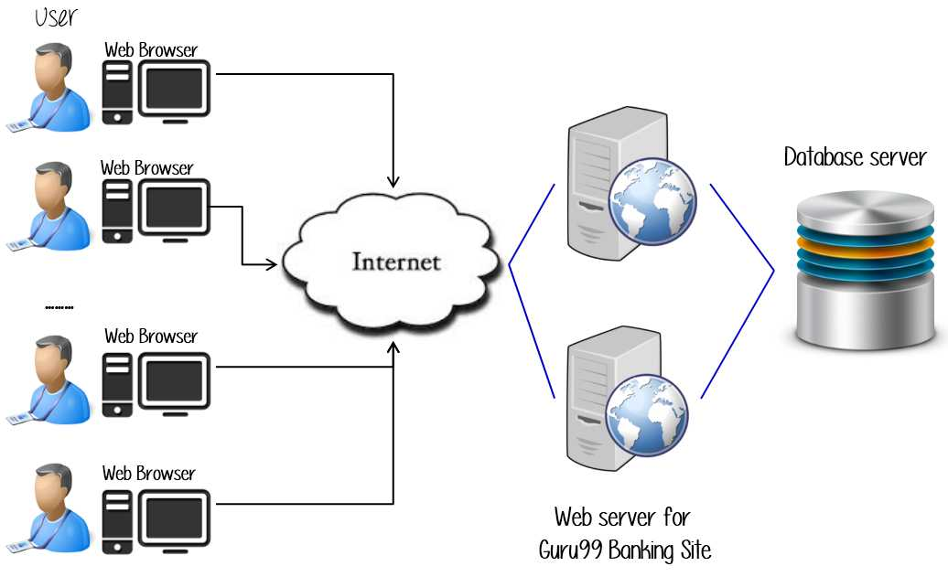
5 TEST ENVIRONMENT

Amazon

6 SCHEDULE & ESTIMATION
6.1 Project Tasks & Estimation
Task | Description | Members | Estimate Effort
Test Planning | Develop a comprehensive test plan that covers all aspects of the system, including outlining limitations of the testing project and project schedule. | QA Tester | 6 man-hours
Test Case Design and Execution | Create detailed test cases and test scripts and execute said scripts | QA Tester | 40 man-hours
Test Reporting | Compile and document the test results, including any defects and their resolution, and communicate the results to the project stakeholders. | QA Tester | 6 man-hours
Total |  |  | 52 man-hours

6.2 Project Schedule
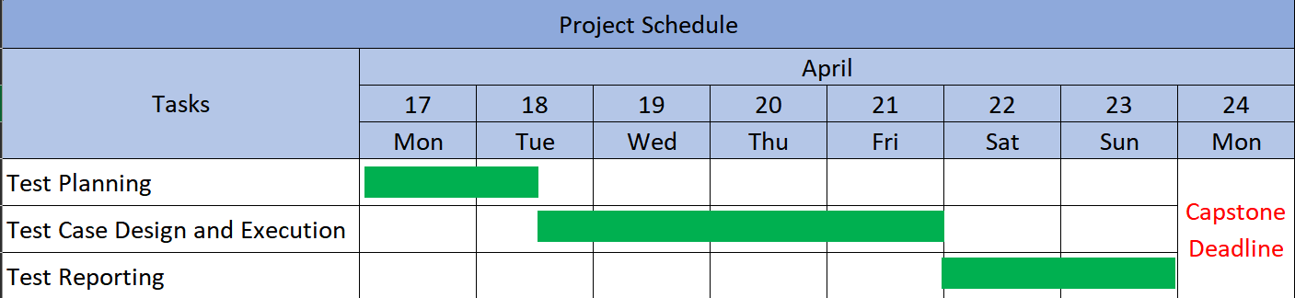

7 TEST DELIVERABLES
Test deliverables are provided as below:
7.1 Before Testing Phase
- Test plans document.
7.2 During The Testing
- Test Tool
- Simulators
- Test Data
7.3 After The Testing
- Test Report
- Video Demo running tests
- Other notable resources required.

